**Deploying Online Boutique Website using GKE cluster**

**Step-1:** Firstly, create a new GCP project or use the existing project.

PROJECT_URL: https://github.com/GoogleCloudPlatform/microservices-demo.git

**Step-2:** Creating GKE cluster

Create a GKE cluster accordingly using needed specification. Now in this project the specifications used for creating cluster are:

# **ZONE** = us-central1-b

* **Machine-type** = e2-standard-2
* **Number of nodes** = 4

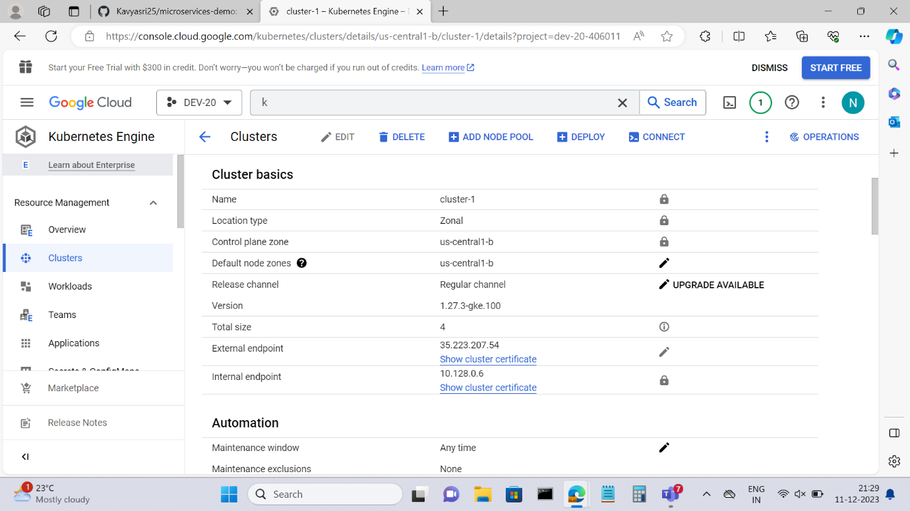

**Step-3:** Cloning the repository.

Once the cluster is created, we need to clone the repository using the below command

git clone <https://github.com/GoogleCloudPlatform/microservices-demo.git>

Now, once the repository got created, we need to get into the directory for that we use

cd microservices-demo

**Step-4:** Deploy the sample app to the cluster

kubectl apply -f ./release/kubernetes-manifests.yaml

here,

**`kubectl apply -f`** is used to apply Kubernetes configuration files to create or update resources in a Kubernetes cluster.

**`-f`** flag specifies the path to the configuration file(s) that you want to apply.

**Step-5:** Get the list of pods in your directory now.

kubectl get pods

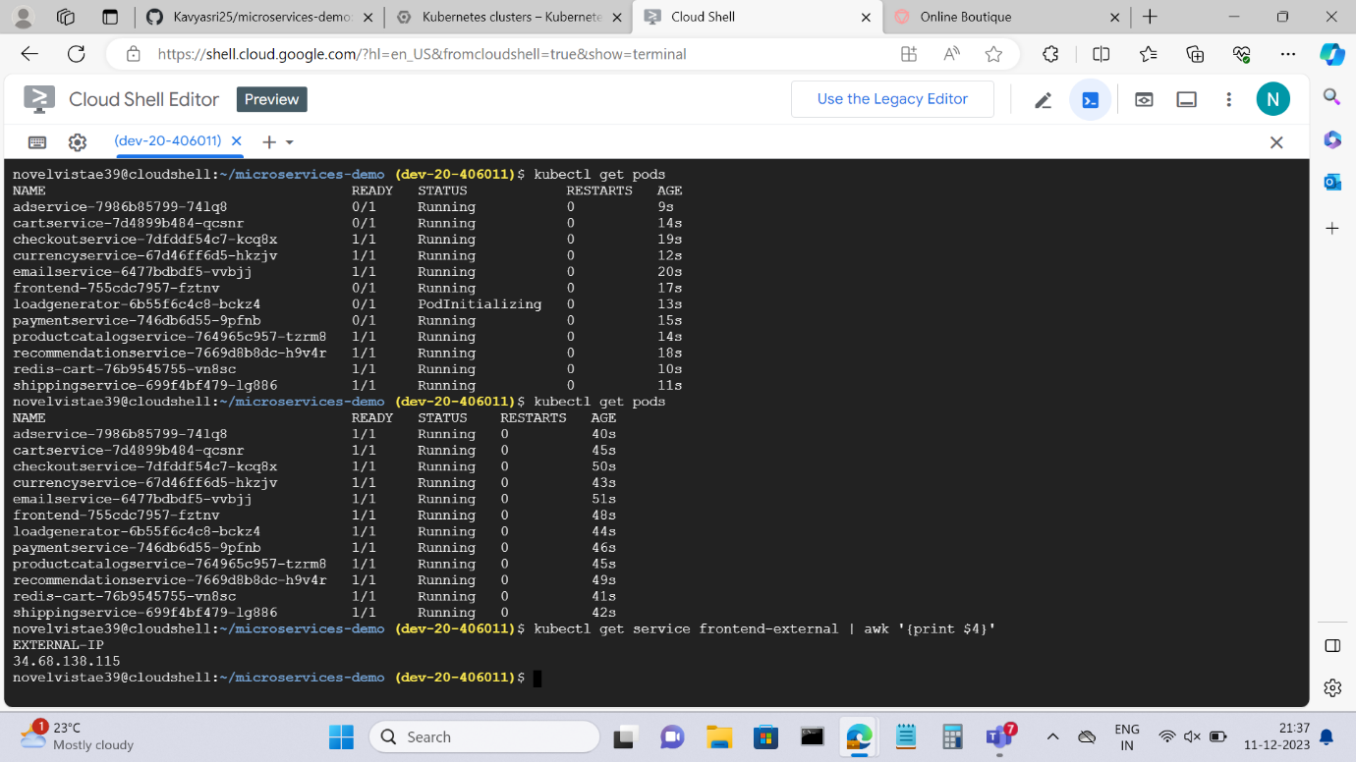

**Step-6:** Get the frontend’s EXTERNAL IP address by using the below command

kubectl get service frontend-external | awk '{print $4}'

**Step-7:** Getting into the final step to look into the result, use the retrieved frontend’s EXTERNAL IP address and access it from the web browser.

